NAJUA 2016 Nominations Vita Form

Picture  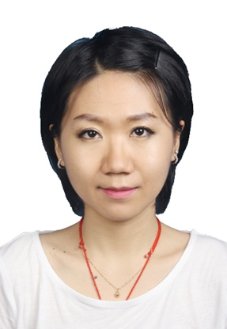 | Nominee Name: Haobing Qian  Position for Nominee: NAJUA Student Representative

Experience (indicate professional, community, and university experience):
PROFESSIONAL EXPERIENCE

The Carter Center
Policy Intern September 2015-December 2015

Pfizer Investment Co., Ltd, Shanghai, China June 2015- August 2015
Summer government affairs intern (public relations and policy)

The Emory Clinic, Revenue Cycle Development Feb 2015-May 2015
Directed Studies Program Intern

University of Missouri-Columbia, Columbia, MO Sep 2013-Dec 2013
Teaching Assistant

Graduate Research Assistant Jan 2011-Dec 2013.
No 9 Hospital, Wuxi, China June 2014- August 2014
Intern in the department of gynecology and obstetrics

VOLUNTEER ACTIVITIES
  - Volunteered in Department of Pediatrics in Wuxi No. 4 People’s Hospital 2008
  - Volunteered in Department of Pediatrics in Xinhua Hospital, Shanghai, China 2007

PROFESSIONAL ORGANIZATIONS
Institute of Food Technologists, member 2011-2013
Rollins International Student Advisory Board member 2015-2016
Education (indicate institutions, degrees, year, and major fields):
College of Public Health, University of Iowa, Iowa City, IA Expected May 2021
PhD Candidate in Health Management and Policy

Rollins school of Public Health, Emory University, Atlanta, GA May 2016
Master of Public Health in Health and Policy (GPA: 3.6)

University of Missouri-Columbia, Columbia, MO December 2013
Master of Science in Food Science. Division of Food Systems & Bioengineering (Cumulative GPA: 3.9)

Jiangnan University, Wuxi, Jiangsu, China May 2011
Bachelor of Science in Food Science and Technology. College of Food Science and Technology (Cumulative GPA: 3.1)

Statement (Vision and Ideas regarding the position nominated with NAJUA):
Vision: To enhance academic collaborations, scientific communications in food science technology and public health between China and the US through my efforts and professional knowledge.
Ideas: as one of the NUJUA student members, I will try my best tot serve the community to establish collaborations between NUJUA and various professional organizations by holding annual meetings, professional conferences for support and mutual growth.

I have discussed the responsibilities of the position with a Nominating Committee member so that I am fully informed of its responsibilities.

Nominee: Haobing Qian
Signature Haobing Qian Date 07/07/2016

